LabVIEW 2009 Demo: Sub Version and Command Line Differencing 1

Backgound 1

Sub Version Control 1

Use Case Example 1

Tortoise Sub Version Control 2

Install Tortoise Sub Version Control 2

Set Up a Repository 2

Import a Project Folder 2

Check out the Folder 2

Update the Environment Path 2

Install LVCompare into TortoiseSVN 2

# LabVIEW 2009 Demo: Sub Version and Command Line Differencing

This demonstration will cover the rudimentary elements of sub version control in LabVIEW and the command line differencing tool. The demo uses TortoiseSVN.

## Backgound

Source Code Control (SCC) is used by many developers and development teams to protect and track data as it is modified.

### Sub Version Control

Sub version is a type of SCC that tracks binary changes to the files. A copy of the file is not saved as a revision, only the incremental changes to the file. The files created by sub version control are not application readable. That used to cause a problem in LabVIEW, since the files not only had the same name but were not really LabVIEW files. Improvements have been made so that LabVIEW can skip sub-version repository folders and also incorporate DIFF into the SCC engine.

### Use Case Example

Consider a team of 4 engineers working on a single LabVIEW application. The application is stored on a shared disk.

Engineer 1 works on an isolated aspect of the application, he has clearly defined input and output parameters and works on stand-alone VIs to fulfill his specification. He uses SCC to keep track of the VIs as he creates them. SCC lets him track changes and revert back to old versions in case a change has broken the application.

Engineers 2-4 all work on the same aspect of the application. They use SCC to “check-out” files. They have configured the SCC software to track changes made my multiple simultaneous editors. For example, Sam and Sally both check out subVI1.vi and make changes. Steve uses SCC to compare the changes made by Sam and Sally (DIFF) and merge the changes into a single new copy (MERGE).

## Tortoise Sub Version Control

Tortoise is a popular open-source free sub version control package.

### Install Tortoise Sub Version Control

1. Visit TortoiseSVN and download Tortoise 1.6.2 32-bit client.
2. Run the install with the default configuration. Restart the computer.

### Set Up a Repository

1. Create a new folder on the root of the C: drive called SVNRepository.
2. Right-click the new folder»TortoiseSVN»Create Repository Here.
3. If you do not get the message that the repository was created successfully, something is wrong.
4. Right-click the new folder»TortoiseSVN»Repo-browser. Copy the entire URL, e.g. “file:///C:/SVNRepository”.
5. Additional help may be found [here](http://tortoisesvn.net/docs/release/TortoiseSVN_en/tsvn-repository.html#tsvn-repository-create-tortoisesvn).

### Import a Project Folder

1. Create a new folder for your LabVIEW project.
2. Right-click the new folder»TortoiseSVN»Import…
3. Paste the URL from the previous step or browse to the repository.
4. Click OK.

### Check out the Folder

1. Right-click the project folder and select SVN Checkout…»OK»OK.
2. Create a new VI in the project folder.
3. The icon for the folder should be a green check.
4. Right-click the project folder»SVN Commit…
5. Select all»OK»OK.

### Update the Environment Path

1. Right-click My Computer»Properties»Advanced»Environment Variables.
2. Select Path from System Variables and click Edit.
3. Add ;C:\Program Files\National Instruments\Shared\LabVIEW Compare to the end of the path string.
4. Close the window.

### Install LVCompare into TortoiseSVN

1. Open TortoiseSVN and select Settings.
2. Select the Diff Viewer Category.
3. Click the Advanced button under Configure the program used for comparing different versions of files.
4. Add .vi with the command line LVCompare %base %mine.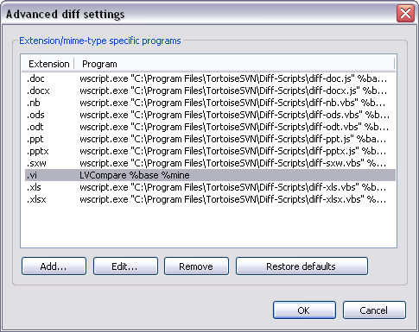
5. Right-click the New VI in the folder»TortoiseSVN»Diff.

